Pseudo base station detection equipment
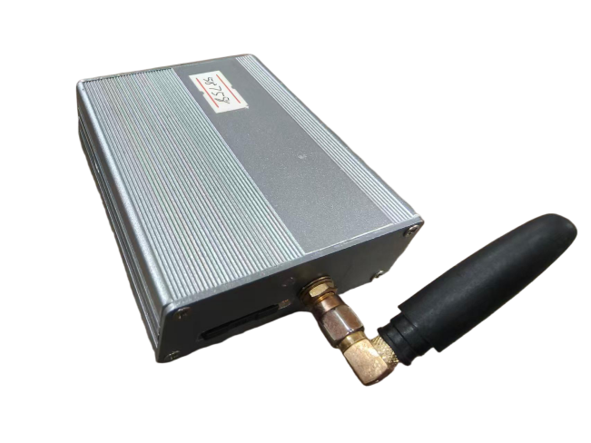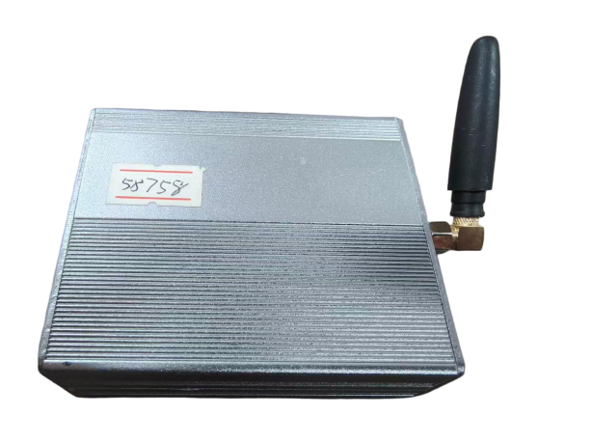
- Device Overview
The false base station detector consists of detection host and positioning unit:
Detective host. Portable design. The size is only the size of a cigarette box. Connect to a laptop via USB. Implement intelligent pseudo base station detection and alarm.
The single-soldier locator is a power detector that can lock onto GSM base station frequencies.When used with the detection host, it features concealment, directional targeting, and portability for individual soldiers.When worn by reconnaissance personnel,it enables accurate and rapid identification of rogue base stations.
- Main Functions and Indicators
Detect surrounding GSM wireless signals and analyze wireless parameters such as LAC, CI, and RSSI.
Simultaneously detects 7 GSM wireless cells, automa-tically analyzes parameters to identify fake base stations, and triggers alerts.
The host sensitivity is-110dBm.
Sensitivity-100dBm.
The single soldier is powered by built-in lithium battery and has a standby time of 6 hours.
The soldier has a directional antenna to quickly find the target.
- Features and Advantages
The UE-specific RF and baseband integrated chip design offers low power consumption, compact size, and high reliability.
Intelligent software design enables fully automatic detection and alarm.
The portable single soldier is equipped with a directional antenna, enabling reconnaissance personnel to quickly determine directions.
The portable single soldier has the function of voice reporting of parameter changes. The investigator can listen to the parameter changes at any time to realize covert investigation.

